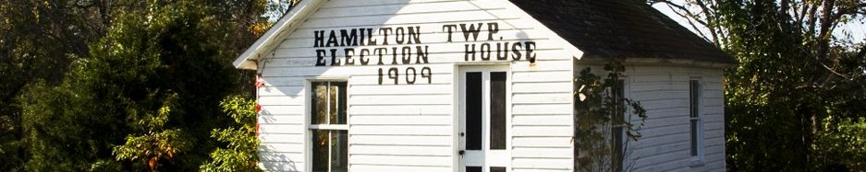

Hamilton township Newsletter
Spring/Summer 2016
Welcome
Hello, Hamilton Township residents. We are hoping to keep you up to date with what is going on here at the township. We will inform you of new changes, and included in this newsletter are some important phone numbers for your use. We hold township meetings regularly, and residents are encouraged to come and voice their concerns
Contact Us
Office: (717) 259–7237
Fax: (717) 259-7255
Email: saehamilton@twphamilton.com
Website: http://twphamilton.com
Hamilton Township Hours
Mon – Fri
Open 8:00 AM – 4:00 PM
Closed Noon – 1 PM

2016 Winter Snow Storm
This past January’s snow storm was a really a bad one. Our road crew was short one man, but they did a terrific job of clearing the snow. We did have the usual complaints and we did our best to handle each one according to its importance. As we look back, we can see areas where we could do better and this is where we need your help. If you are a medical professional, or a job essential person; we need to know. If you have a person with special needs that would need assistance, we need to know. We need to know if you are a farmer or construction worker with equipment that could be used to assist the Township during storms like this one.
The assistance from construction or farm owners would be very much appreciated. Anyone wanting to help, should please contact our office. Included with this newsletter is a short questionnaire that we are asking residents to fill out and return to the Township Office. This will be valuable information for the Township and for our Emergency Mgmt. Coordinator.
ACTPO – Adams County Transportation Planning Organization
ACTPO was formed in 1999 and became a Metropolitan Planning Organization in 2013. ACTPO prioritizes and allocates federal, state and local transportation funds for roads, bridges, bicycle/pedestrian, safety, and public transit. ACTPO identifies transportation improvements necessary to move people and goods throughout the area as quickly and safely as possible. They must consider all modes of transportation, including roads, bicycles, pedestrians, transit, railroads and airports. Some of ACTPO’s future projects include state and local bridges and congestion management.
ACTPO says that right now, the most pressing and important news to our residents are the bridges that are on the Penn Dot list for scheduled closure for badly needed repairs or replacement all around the County. You can get updated information on which bridges are affected and when repairs or replacements will take place by checking out ACTPO minutes and distributed documents that can be found at www.adamscounty.us/Dept/Planning.
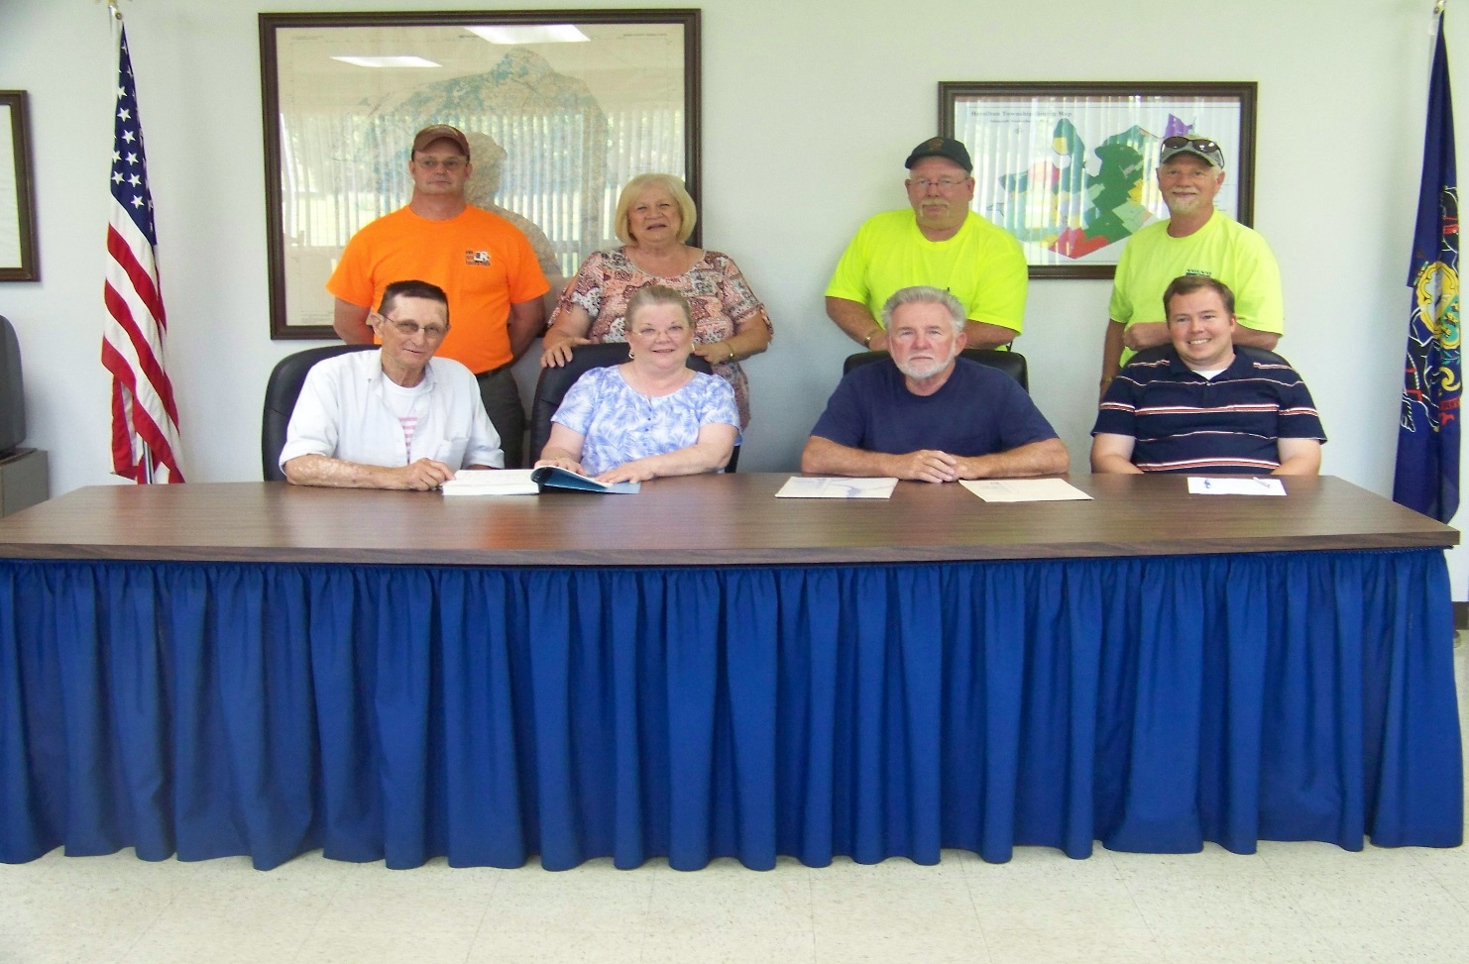
Hamilton Township staff: (sitting from left to right) Supervisor, Timothy D. Beard III; Supervisor/Office Mgr., Stephanie A. Egger; Supervisor, Ron L. Weidner; Zoning & Permit Officer, Wesley Winner; (standing from left to right) Road Crew, Tom Barrows; Secretary, Debby Brogan; Roadmaster, Jay Livingston; and Road Crew, Tony Long.
From the Road Crew…
Speaking of bridges, our Township is in the process of planning the replacement of two bridges which we share with Paradise Township. They are on Protectory Road and Home Road. These bridges have been posted since March 2016. Please put safety first when using these bridges. Hamilton & Paradise Townships hope to begin replacing these bridges in 2017.
The road crew will soon begin working on the roads along with Hammaker East. They will be doing chip seal on the following roads: Forest Drive – Brough Road to Woods Road; Locust Lane – Rt. 194 to Pine Run Road; Kuhn Fording – Pine Run to Winding Lane; Woods Road – Pine Run Road to Township Line; Waldheim Road and Spangler Road – Gun Club to 700 Road. At Kuhn Fording and The Spangler Road they will be replacing culvert pipe.
Our road crew continues to work on mowing, pot-hole repairs and making sure our roads are safe and passable.
From the Secretary…
Like many of you, I am so glad that summer is finally here. I just returned from the 94th Annual Educational Conference and Trade Show of the PA State Association of Township Supervisors (PSATS) in Hershey! Close to 4,000 township officials, exhibitors, and guests participated. I really had a great time networking with other township officials and secretaries! I was there for three days and attended many workshops and meetings. Every morning there was a General Session with notable speakers like Governor Tom Wolf, U.S. Congressman Lou Barletta, Pa. Senate Majority Leader, Jake Corman, Pa. Senator Eugene Yaw, Auditor General Eugene DePasquale, Political Analyst and Director of the Center for Politics and Public Affairs at Franklin & Marshall College, Terry Madonna and special Keynote Speaker, Kim Coon.

As secretary, there are a couple of things I want to remind you:
Tenant reporting is very important. Please remember to file your Landlord/Tenant forms with our office. These forms should be filed each year between January 1st and 15th; the form is on our website http://twphamiton.com. Then any time there is a change in tenant, a new form must be filed. These requirements are from our Township Ordinance #53 and is available at the township office for your review.
Septic pumping must be done every three years. Reminders were sent out for those residents that needed to pump this year. As a reminder, we still have some reports due from 2015. We will be sending out another reminder very soon.
On the last page of this newsletter is a form that we would appreciate being filled out and returned to our office. This information will remain in this office and will not be shared. As stated in the article about the snow storm, this will assist us in getting you out during a snow storm, having email delivery of notices and this newsletter. We thank you in advance for providing this information.
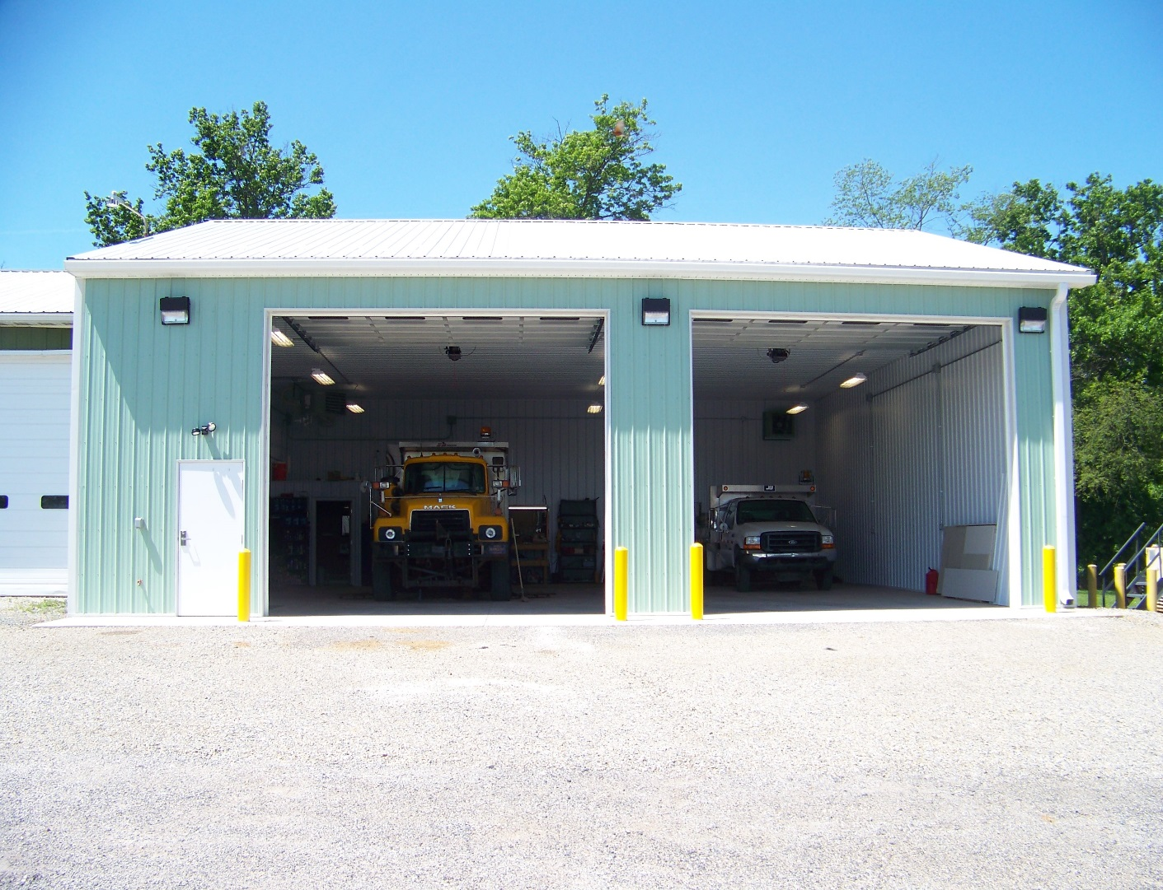
This is our new garage. We now have the housing capacity for our big trucks. We are able to park them with the plow still attached, and do maintenance work inside. We also installed a safety station, shower and bathroom.
Old Photos…
The Township is looking for old photos from around the township to publish in our Newsletter. If you have any photos that you wish to contribute, we would be delighted to share them. We have the ability to scan the photos, which means that we would be able to return your originals. Please indicate what and where the photo was taken; and who is in the photos and the date taken. The more information we have about the pictures the better. We would also need your information. This is a fun project for our next Newsletter in the fall.

We’d like your help…
In the late 1850’s, a Mr. Harry Hoffman lived in our township. We were informed by a family member that The Hoffman home was once used as the township voting location. Does anyone have any information about Mr. Hoffman and/or the location of his 1850 home?
From the Adams County Fire Chief’s Association…
“We can’t help you if we can’t find you!”
Every second counts during a fire or other emergency. Valuable time can be lost if your address number is not clearly posted where firefighters can see it. Please post your address number where it is clearly visible from the street. A clearly visible address number on your mailbox is important to emergency personnel. House numbers should be at least 3” high and you should install a light fixture above the numbers. If you have a curbside mailbox, reflective numbers should be placed on the front and both sides. It’s easy to put off numbering your house and mailbox. Don’t wait until you need emergency assistance. If you don’t have highly visible numbering on your house and mailbox, do it today!

From the Zoning, Code Enforcement, and Planning Office:
A reminder for grass and weeds: All yards should be maintained at no more than 8” in height. All fallow fields (fields not currently producing crops), should be maintained at a height of 12” and should be maintained free of noxious weeds. All mulching hay should also be maintained at height of 12” after August 15.
Home Improvements: It is that time of year when many people complete home and outdoor improvements. As a reminder, all projects that create new impervious surfaces (such as patios, swimming pools, and decks) do require a permit. Fences require a permit also. Any work on the interior of the home may require a permit if there is major electrical work, plumbing work, or if you’re moving or changing anything on a load bearing wall. If you are making “repairs” to your house or your roof you will not need a permit, however if your adding new items or making a substantial change you will likely need a permit. Please call me at 717-259-7237 on Tuesday or Thursday (8:00-4:00) if you have any questions.
Planning & Development: New Home construction continues in Cedar Ridge, and the development is nearly built out. We also are continuing to see residents make investments on their existing properties, this shows a commitment to remaining in Hamilton Township. The Cross Keys Community Park has started building trails, pavilions and other features that will make this a valuable asset for Hamilton Township. With these additions and improvements, Hamilton Township continues to be an attractive place to live and work.
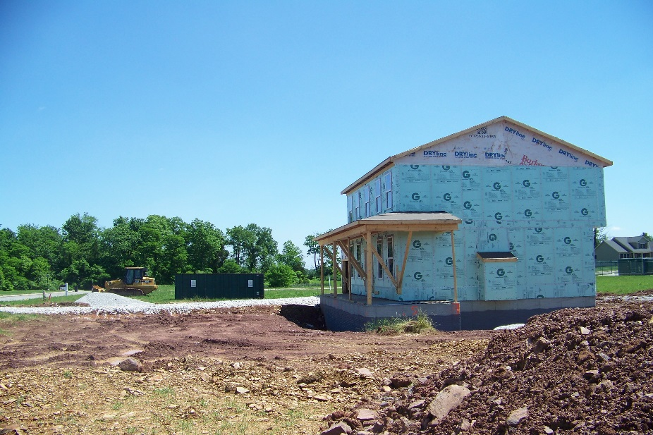 Cedar Ridge

From the Emergency Management Coordinator:
So far in 2016 we have had no floods, fires or other major emergencies in the Township except for the big snow storm. We learned from that storm that our preparations weren’t sufficient for the situation.
We have taken steps to correct the problem areas, however, we need your help as follows: All medical people in the township should provide us with their names, addresses, phone numbers and medical affiliations. This will permit our personnel to open their roads, first priority in emergencies. Please take a few moments to fill out the questionnaire on the back and send it to the township office. All the information will be kept confidential. Thank you in advance for your cooperation.
Upcoming Events…
SPCA Collection: We continue to collect items for the Adams County SPCA for the care of the animals at the shelter: Blankets, rugs, food and toys in good shape are some of the items collected. A complete list of their needs is available at the Township Office.
Ronald McDonald House: The Township continues to collect glossy paper magazines, the glossy newspaper inserts, etc. for the Ronald McDonalds House. Collection box is in the lobby of the Township Office.
The Double Creek Bicycle Tour will be coming through our township and there will be stop at our Township Building. The Tour, sponsored by Wellspan Health, will be on Saturday, June 18th from 7:00-2:00 pm. They are raising funds for prescriptions for low income people.
East Berlin Community Library will be having their Grand Opening on Sunday, July 24th from 2:00 – 5:00 pm.
Dates for your calendars…
The Township Office will be closed on the following dates:
July 4th for Independence Day
September 5th for Labor Day
November 24th – 25th for Thanksgiving
December 26th – 27th for Christmas
January 2nd for News Years Day
Our Re-Organizational Meeting & Board of Supervisors Meeting will then be held on Tuesday, January 3rd @ 6:30 pm

October 31st will be Trick or Treat night
Tuesday, November 8th is Election Day

INFORMATION FORM
Name ____________________________________
Address, City, Zip ______________________________________________________________________
Closest Cross Street _________________________________
Telephone / Cell #’s _________________________________ Email address _______________________
Occupation _______________________ Place of Employment __________________________________
Work Hours ___________________________
Can you help? Yes ___ No ___ Equipment Available _________________________________________ _____________________________________________________________________________________
License # ________________ CDL Y/N
Liability Insurance Y/N Must Provide Certificate of Liability Insurance if you assist
Comments ___________________________________________________________________________
____________________________________________________________________________________
____________________________________________________________________________________
Please complete this form and return to the Township Office. Thank you for your help and willingness to
help improve your Township.

This is the second Newsletter that we have provided. If you feel that our Newsletter is providing valuable information, is useful, and you feel we should continue; please let us know. We welcome your suggestions, comments and criticisms.
Yes _______ No _________
Comments:

