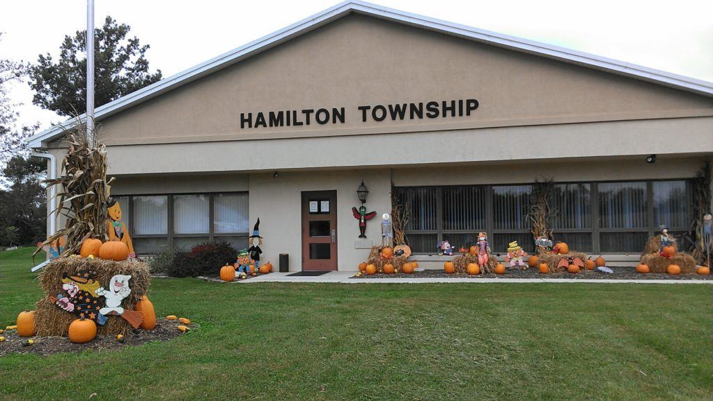

Hamilton township Newsletter
Fall/Winter 2016
Welcome
Hello, Hamilton Township residents. We are hoping to keep you up to date with what is going on here at the township. We will inform you of new changes, and included in this newsletter are some important messages for you. We hold township meetings once a month, and residents are encouraged to come and voice their concerns.
Hamilton Township Hours
Mon – Fri
Open 8:00 AM – 4:00 PM
Closed Noon – 1 PM
Contact Us Office:
(717) 259–7237
Fax: (717) 259-7255
Email: saehamilton@twphamilton.com
Website: http://twphamilton.com

Dates for your calendars…
The Township has regular Board of Supervisors meetings on the first Monday of each month. All residents are welcome to attend and voice their concerns over issues facing the township.
Dog Licensing
What are Pennsylvania’s dog licensing requirements?
1. All dogs, three months or older, must be licensed by January 1st of each year. License go on sale December 1st for the upcoming license year.
2. An annual license is $8.50 and a lifetime license is $51.50. If the dog is spayed or neutered, the annual fee is $6.50 and lifetime is $31.50. Prior to obtaining a lifetime license, a dog must have a microchip or tattoo. Discount licenses are available to older adults and people with disabilities.
3. All dogs and nonferal cats, three months of age and older, must be vaccinated against rabies.
4. Violators can be cited with a maximum fine of $300 per violation plus court costs.
5. Licenses may be purchased through your county treasurer.
Why get your dog licensed?
1. If your dog gets lost, a current license is the fastest way for your dog to be reunited with you.
2. Stray dogs without current licenses can be taken to shelters far from their homes and adopted after 48 hours if no owner is identified.
General Dog Law Information
1. The Bureau of Dog Law Enforcement is responsible for ensuring the welfare of all dogs and puppies in kennels, regulating dogs classified as “dangerous,” and overseeing annual licensure and rabies vaccinations for dogs.
2. Complaints or tips may be submitted to the Bureau of Dog Law Enforcement at www.licenseyourdogPA.com or by contacting your local dog warden.

Share the Love: Make Sure Your Dog is Licensed
Dogs have often been referred to as man’s best friend. Like “Buster Egger,” pictured here, they are the first ones to greet you at the door and are happy to sit next to you while you read or catch up on the daily news. They are more than companions, they become members of the family. Licensing your dog is the right thing to do – it’s the right thing for your pet, and it’s the law.

Mailbox Policy (Resolution #2016-47 approved 3/7/2016)
The Board of Supervisors approved a mailbox policy last March; it states as follows:
“Because the post office has certain placement requirements regarding the location of mailboxes, the Township does not prohibit property owners from placing mailboxes within the limits of the legal right-of-way. Since these mailboxes are not placed under permit regulations, technically they are encroachments, and remain at the risk of the property owner. Therefore, the Township is not liable for damages to mailboxes caused by snow removal when they are located within the limits of the legal right-of-way.” Homeowners who have had difficulties in the past may want to consider installing a cantilevered mailbox support that will swing a mailbox out of harm’s way. If you have any questions about this Resolution, please give us a call.
Hamilton Township Welcomes our New Zoning / Code Enforcement Officer

Please join us in welcoming Scott Weaver to Hamilton Township. Scott will be serving as our new Zoning / Code Enforcement Officer. Scott, a resident of Hamilton Township, comes to us from PA Municipal Code Alliance, Inc. Scott’s hours will be Tuesday and Thursday, 8:00 am to 4:00 pm (12:00 to 1:00 lunch). He can be reached here at 717-259-7237 ext. 105 or emailed at scott@pacodealliance.com.

Volunteers Are Needed to serve on our Parks & Recreation Board
The Township is still in need of volunteers to serve on the Parks & Recreation Board. Currently the Parks & Recreation Board is working on a Rail Trail along the old train tracks at Conewago Creek from Pine Run to East Berlin.
The Board wants to thank Paul Minnick and Torren Ecker for volunteering to serve on the EBACC Board. There is always something going on at this Community Center, check out their web-site for events and activities at: www.ebacc.org
from the Roadmaster…
Jay Livingston and the Road Crew are ready for the winter season, which has failed to make an entrance this season, so far! The crew has attached the plows to the trucks, made sure we have enough salt and anti-skid, and analyzed the plowing route to best help our residents. If you are out and pull up behind our plow, please remember that if you can’t see their side mirrors, they can’t see you. Earlier we asked that if you are a first responder for the Fire Company an EMT, or a doctor or nurse; and you need to report to work; please let us know. We can arrange to plow you out first or as soon as possible. What we need is good communication. Stop at the office and complete a request.
The Road Crew also asks that you help us keep the swales and gutters free of debris, such as leaves, etc. Also, please use your good judgement when you want to burn, call the township office for burning information.
Lastly, bids are now being accepted for paving work on Old Mill Road. Work can begin after April 15th. Bids will be opened at our Board meeting on March 6th.

Hamilton Township Planning Commission

Our Planning Commission consists of five (5) members. They meet on the third Tuesday of each month to review the zoning ordinances, sub-division and land development ordinances, official maps, provisions for planned residential development, and such other ordinances and regulations governing the development of land. They then make recommendations concerning land development and sub-divisions, and zoning issues to the Board of Supervisors and the Zoning Hearing Board. Next time you see one of these members, take a moment to thank them for their service to the township.

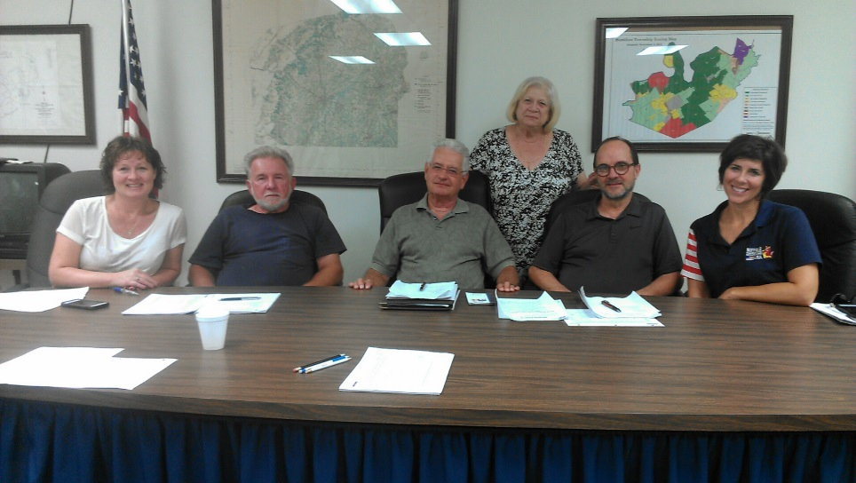
Left to Right: Christine Myers, Ron Weidner, Mel Lebo, Ira Bitner, Lela Reichart, Debby Brogan (standing)
Currently they are working with the development of a Sheetz Store at the Cross Keys intersection. The Planning Commission will review and send recommendations to the Board of Supervisors for approval.
from the Secretary…
As we begin the New Year, I have a few reminders for you. If you are a landlord, I have a form that needs to be filed in our office advising us of the names of the tenants. According to Ordinance #53, which states that landlords are to file annual reports listing all rental or rentable units, tenants, or occupiers to the Hamilton Township Secretary between January 1st and 15th of each year. This is required to be done every year even if there is no change.
Septic Pumping: Please remember that if you had your septic pumped in 2013, you were due to have your system pumped again in 2016. Remind your haulers to send a report of pumping to the Township office. Failure to have septic pumping done can and will result in fines. Residents that had their septic pumped in 2014 will need to have them pumped again in 2017. Reminders will go out in January.
Vehicle Registration Stickers - Beginning Dec. 31, 2016, PennDot will no longer issue vehicle registration stickers. Vehicles must still be registered; however, the elimination of the registration sticker will result in a cost savings to taxpayers of more than $1 million per year. An additional $2 million is estimated to be saved in mailing costs.
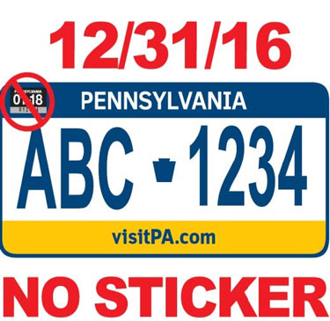

Who remembers the old Hamilton Township Election house? The house is still standing, however, it has been painted over. Back in the day, this location was used as the township election house. An old Ben Franklin stove kept you warm while you took care of business. Let us know what you might remember about this old building?
Dates for your calendar…
March: April:
3/6/17 Board of Supervisors Regular meeting at 7:00 pm 4/3/2017 BOS Regular meeting at 7:00 pm
3/12/2017 Daylight Savings Time (Spring Forward!) 4/11/2017 Parks & Recreation Board meeting at 7:00 pm
3/14/2014 Parks & Recreation Board meeting at 7:00 pm 4/16/2017 Easter Sunday!
3/17/2017 St. Patrick’s Day 4/18/2017 Planning Commission meeting at 7:00 pm
3/20/2017 1st Day of Spring! 4/26/2017 Administrative Professionals Day
3/21/2017 Planning Commission meeting at 7:00 pm

May:

5/1/2017 Board of Supervisors Regular meeting at 7:00 pm
5/9/2017 Parks & Recreation Board meeting at 7:00 pm
5/14/2017 Mother’s Day
5/16/2017 Planning Commission meeting at 7:00 pm
5/29/2017 Memorial Day – Our office will be CLOSED

